Safety Alert | Coronavirus COVID-19

A: 23 Vivaldi Ave, Stirling Perth WA 6021
P: 0403306635
E: service@getcleaned.com.au
W: https://GetCleaned.com.au

Safety Manual

Coronavirus COVID-19 - Our Commitment to our Workers
Get Cleaned Pty Ltd is committed to ensuring the health and safety of all its employees. The Coronavirus is affecting over one million people globally with the Government of Western Australia Declaring a State of Emergency and Public Health Emergency in response to the Coronavirus COVID-19.
Whilst we are undergoing this pandemic, we will endeavour to keep our staff informed on any developments that is provided to us. It is also important that the employees of Get Cleaned Pty Ltd in accordance with the Health, Safety & Environment manual it is important to maintain a safe working environment both for yourself and that of your work colleagues. During this period and until advised otherwise it is imperative that we follow the guidelines and strict instructions that the Western Australian Government has implemented across the State.
It is advisable that you maintain abreast of developments either via television broadcasts, radio broadcasts and/or internet publications, as situations and circumstances change via the Government announcements which may impact our ability to undertake our duties which we will discuss and take reasonable steps to lessen any burden which may affect you and your family.
This information booklet dedicated to the Coronavirus [COVID-19] must be read and acknowledged by all staff. It is important that you fully understand the requirements, instructions and adhere to the Government rulings for us to continue working and maintaining a safe environment for everyone.
Upon distribution and discussion of this information booklet, should you have any concerns please ensure you contact me to discuss and clarify any questions you may have.
Your cooperation is paramount during this pandemic, and I congratulate you all to date in maintaining a high standard work ethic and following procedures.
We are all in this together and together we will overcome the hurdles ahead of us.

George Garrett - Director

A: 23 Vivaldi Ave, Stirling Perth WA 6021
P: 0403306635
E: service@getcleaned.com.au
W: https://GetCleaned.com.au
Coronavirus [Covid-19] Explained
1. What is Coronavirus [Covid-19]?
Coronaviruses are a large family of viruses that cause respiratory infections. These can range from the common cold to more serious diseases.
COVID-19 is a disease caused by a new form of Coronavirus. It was first reported in December 2019 in Wuhan City in China.
2. Symptoms
Symptoms can range from mild illness to pneumonia. Some people will recover very easily, whilst others may get extremely ill which can be life threatening.
People with Coronavirus may experience:
- Fever.
- symptoms such as coughing, a sore throat & fatigue; shortness of breath.
3. How it spreads - The virus can spread from person to person through:
- close contact with an infectious person [including in the 24 hours before they had symptoms];
- contact with droplets from an infected person’s cough or sneeze.
- touching objects or surfaces [like doorknobs or tables] that have droplets from an infected person, and then touching your mouth or face.
COVID-19 is a new disease there is no existing immunity in our community, meaning that COVID-19 can spread widely and quickly so PROTECT YOURSELF & OTHERS.
4. Protect Yourself & Others
Everyone must do the following to slow the spread of COVID-19 and protect those that are most at risk:
- Good Hygiene
- Social Distancing
- Public Gatherings
- Self-Isolation

A: 23 Vivaldi Ave, Stirling Perth WA 6021
P: 0403306635
E: service@getcleaned.com.au
W: https://GetCleaned.com.au

Figure 1: Protect Yourself & Others - issued by the Government of Western Australia – Department of Health

Preparing our Workforce
5. The Vulnerable
Vulnerable people are, or are likely to be, at higher risk of serious illness if they are infected with COVID-19.
They include:
Aboriginal and Torres Strait Islander people 50 years and older with one or more chronic medical conditions.
- People 65 years and older with chronic medical conditions.
- People 70 years and older.
- People with compromised immune systems.
The advice of the Australian Health Protection Principal Committee (AHPPC)should be followed regarding vulnerable people in the workplace.

A: 23 Vivaldi Ave, Stirling Perth WA 6021
P: 0403306635
E: service@getcleaned.com.au
W: https://GetCleaned.com.au
6. Minimising the Risk of Exposure to COVID-19
Get Cleaned Pty Ltd always shall communicate clearly & honestly with their staff. We will ensure that the work site you are attending is safe to do so by liaising with the client and maintaining regular updates.
We all have a duty of care for the safety of ourselves, our work colleagues, clients, and public. To ensure any risks to our employees are eliminated or minimised as much as reasonably practicable.
This booklet together with the HSE Safety Manual provides guidance and our expectations of our employees and provides information to assist with managing the risks of contracting Coronavirus COVID-19.
6.1 Our employees must stay away from the workplace when:
- you have symptoms which resemble that of Coronavirus.
- you are not feeling well.
- you suspect you may have been in contact with someone that may have had the Coronavirus.
- travelled overseas recently.
If you are concerned you may have COVID-19:
- use the symptom checker available at https://www.health.gov.au/resources/apps-and-tools/healthdirect-coronavirus-covid-19-symptom-checker
- seek medical advice, if you wish to speak to someone about your symptoms contact the National Coronavirus Helpline 1800 020 080 for advice available twenty-four hours, seven days a week.
Keep your employer informed. As a worker you have a duty to take reasonable care of your own health and safety, not adversely affect the health and safety of others and follow our policies and directions. This includes not attending the workplace if you have contracted the COVID-19 virus.
Testing Criteria further expanded in Western Australia for COVID-19. The testing criteria for Coronavirus has been expanded significantly effective, Thursday 9th April 2020 at all COVID-19 Clinics and testing sites across Western Australia.
The testing criteria has been expanded to include anyone who:
- presents with fever at or above 38 degrees Celsius.
- has a history of a fever in the last few days; OR has an acute respiratory infection, e.g., shortness of breath, cough, sore throat etc.

A: 23 Vivaldi Ave, Stirling Perth WA 6021
P: 0403306635
E: service@getcleaned.com.au
W: https://GetCleaned.com.au

A: 23 Vivaldi Ave, Stirling Perth WA 6021
P: 0403306635
E: service@getcleaned.com.au
W: https://GetCleaned.com.au

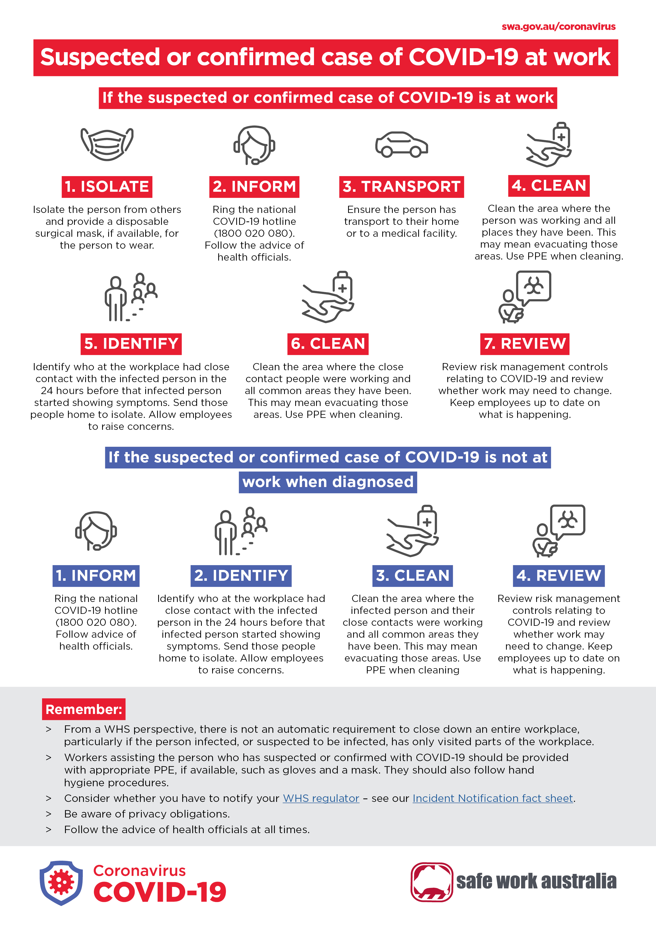

Figure 2: Suspected or Confirmed case of COVID-19 at Work & Not Diagnosed at Work issued by Safe Work Australia

6.2 Preventative Measures
All employees of Get Cleaned Pty Ltd as a requirement must follow and adhere to all the preventative measures to avoid risk of contracting Covid-19 or spreading the Coronavirus.
The risk for cleaning staff is not the same as the risk when face to face with a sick person who may be coughing or sneezing.
In addition to our Cleaning Procedures & Safe Work Practices it is important that you:
- avoid touching your face, especially mouth, nose & eyes when cleaning.
- wear impermeable disposable gloves and a surgical mask plus eye protection or a face shield whilst cleaning.
- use alcohol-based hand rub before putting on and after removing gloves.
- use alcohol-based hand rub before and after removing the mask and eye protection.
Use of Disinfectant
- Use freshly made bleach solution and follow manufacturer’s instructions and/or safe operating procedures for appropriate dilution and use.
- Wipe the area with bleach solution using disposable paper towels or a disposable cloth.
- Dispose of gloves and mask in a leak proof plastic bag.
- Wash hands well using soap and water and dry with disposable paper or single-use cloth towel.
Vehicles
- Company and/or personal vehicles must be maintained in a clean manner.
- Ensure all hard surfaces are wiped down daily.
- Do not leave personal belongings in vehicles.
Important: Cleaning Procedures stipulate the correct process of cleaning equipment, ensure that all equipment is cleaned after use to avoid contamination.

A: 23 Vivaldi Ave, Stirling Perth WA 6021
P: 0403306635
E: service@getcleaned.com.au
W: https://GetCleaned.com.au

6.3 Help Stop the Spread!

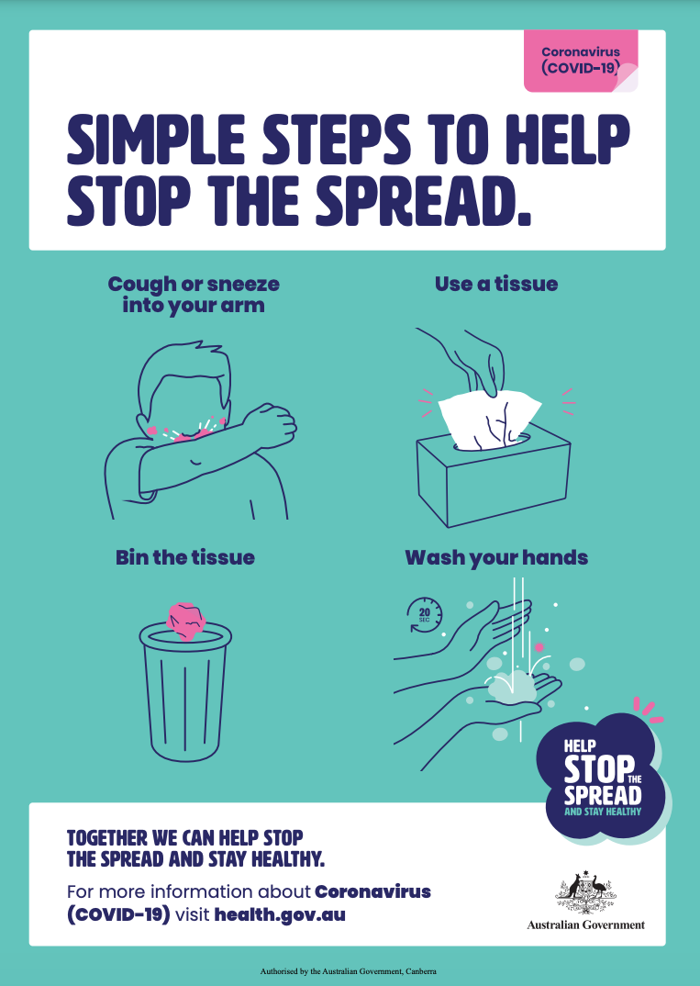

Figure 4: Simple Steps to Help Stop the Spread. Issued by the Australian Government Health Department

A: 23 Vivaldi Ave, Stirling Perth WA 6021
P: 0403306635
E: service@getcleaned.com.au
W: https://GetCleaned.com.au

Figure 3: Help Stop the Spread Issued by Health.gov.au Website
Hand Hygiene
Soap and water should be used for hand hygiene when hands are visibly soiled and alcohol-based hand rub at other times (e.g. when hands have been contaminated from contact with environmental surfaces). Cleaning hands also helps to reduce environmental contamination.
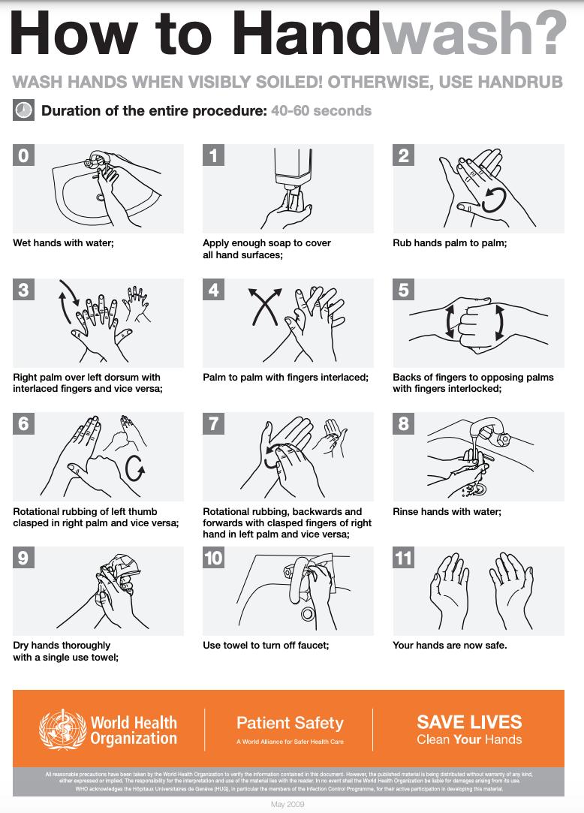
Figure 5 How to Hand Wash? Issued by the World Health Organization

A: 23 Vivaldi Ave, Stirling Perth WA 6021
P: 0403306635
E: service@getcleaned.com.au
W: https://GetCleaned.com.au

A: 23 Vivaldi Ave, Stirling Perth WA 6021
P: 0403306635
E: service@getcleaned.com.au
W: https://GetCleaned.com.au

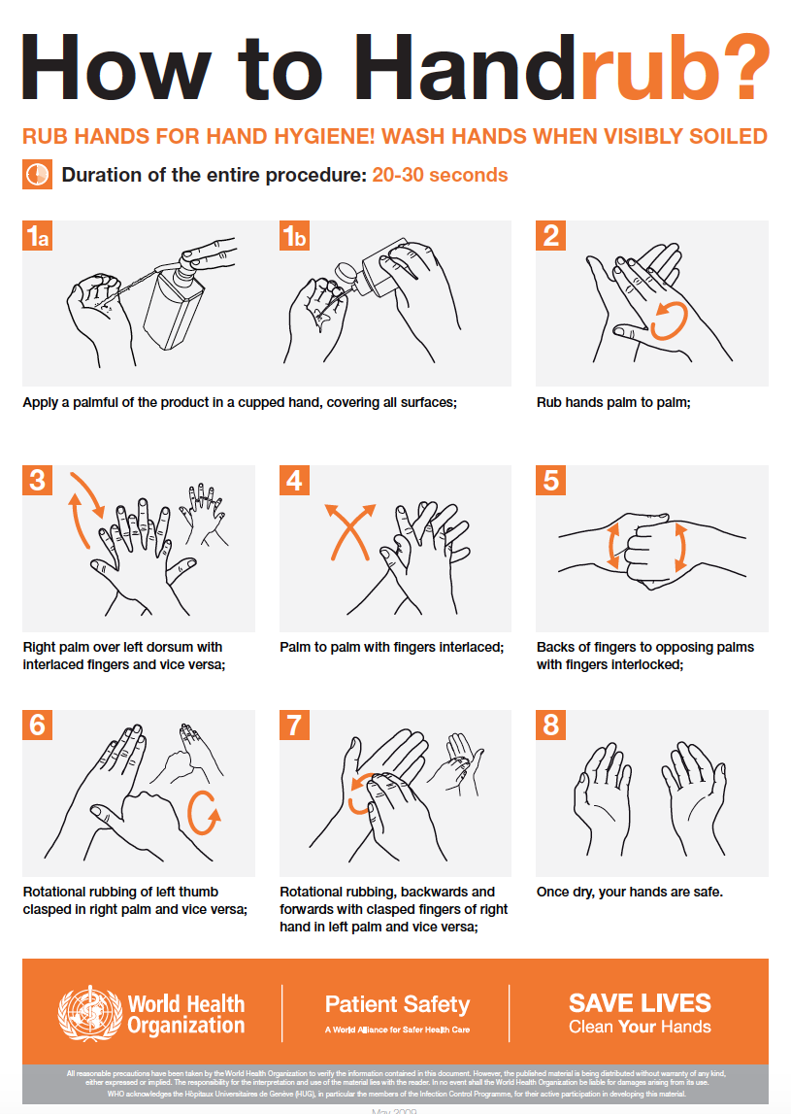

Figure 6: How to Hand Rub. Issued by the World Health Organisation

A: 23 Vivaldi Ave, Stirling Perth WA 6021
P: 0403306635
E: service@getcleaned.com.au
W: https://GetCleaned.com.au
Keep your Distance
Social Distancing limited to two people, is integral to help limit the risk of COVID-19 spreading throughout the Community.
- Keep your distance – stay 1.5 metres apart.
- Do not shake hands or exchange physical greetings such as hugging & kissing
- Cough or sneeze into your arm.
- Stay at home when not at work.
- Only go out, when necessary, e.g., medical, shopping for essential items.
- Clean surfaces and objects regularly.
- Use tap and pay instead of cash.
- Regularly wash your hands throughout the day between 40-60 seconds.
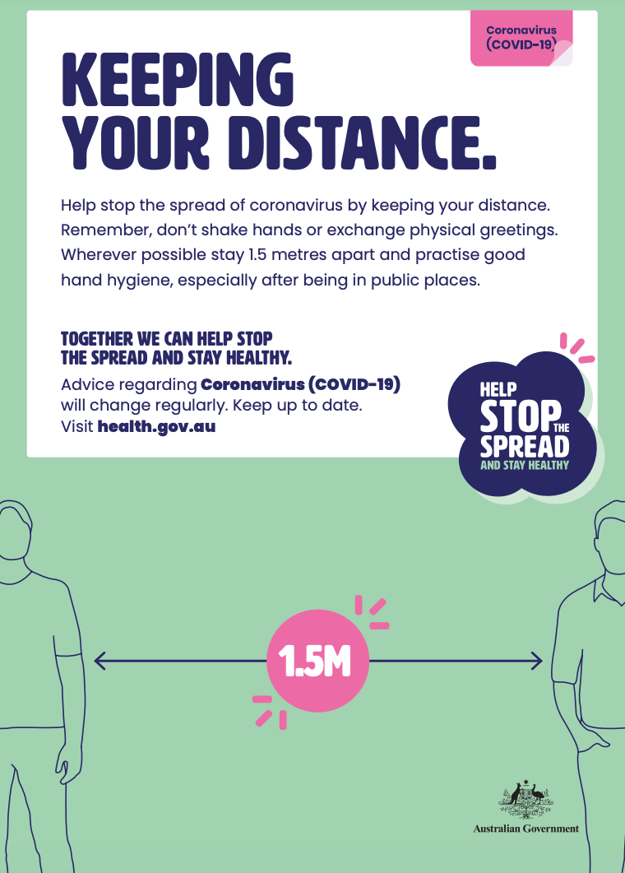
Figure 7: Keeping your Distance issued by the Australian Government Health Department

A: 23 Vivaldi Ave, Stirling Perth WA 6021
P: 0403306635
E: service@getcleaned.com.au
W: https://GetCleaned.com.au
Self-Isolation

A: 23 Vivaldi Ave, Stirling Perth WA 6021
P: 0403306635
E: service@getcleaned.com.au
W: https://GetCleaned.com.au
All Australians must self-isolate if:
- they have COVID-19.
- have been in close contact with a confirmed case of COVID-19.
- arrived in Australia after midnight on 15th March 2020.
- If this applies you must stay at home for 14 DAYS and self-isolate.

If you suspect you have COVID-19, you must:
- isolate yourself (self-quarantine) and advise management immediately.
- inform their management and call a doctor or hospital and tell them their recent travel or close contact history.
If they have serious symptoms such as difficulty breathing call 000, ask for an ambulance and notify the officers of the recent travel or Covid-19 close contact history.

National Cabinet also advises Australians:
> over 70 years of age
> over 60 years of age who have existing health conditions or commodities, and
> indigenous Australians over the age of 50 who have existing health conditions or commodities, should self-isolate to the maximum extent practicable, limiting contact with others as much as possible when they travel outside.
Where vulnerable workers undertake essential work, a risk assessment shall be undertaken.
Travelling to and within Western Australian
To assist in reducing the spread of COVID-19 the WA Government has introduced further restrictions on travel to and within Western Australia. The Government has temporarily closed the Western Australia border, prohibited travel between the four local Government areas within the Kimberley region and Western Australians are only permitted to travel within their designated region.

Regions are:
- Perth and Peel (due to their proximity, the Perth and Peel regions will form one region)
- South West
- Great Southern
- Goldfields-Esperance (stronger restrictions apply)
- Mid-West
- Wheatbelt
- Gascoyne
- Pilbara (stronger restrictions apply to parts of the Shire of East Pilbara)
- Kimberley (stronger restrictions apply to the entire Kimberley region).
Reference: WA regional boundaries map

Exemptions apply for:
- people travelling to work
- attending medical appointments
- transporting freight
- those who do not have access to groceries or supplies within their region
- returning to a place of residence

A: 23 Vivaldi Ave, Stirling Perth WA 6021
P: 0403306635
E: service@getcleaned.com.au
W: https://GetCleaned.com.au
- attending school or an educational institution where necessary
- caring for family members
- compassionate grounds.

There are exemptions in place for people travelling to and from work. Should the Government of Western Australia enforce that a driver must provide an Exemption to Travel Declaration (as per requirements of the Border Closure Entry Approval), Get Cleaned Pty Ltd will complete these forms as and / if they become available on the WA Government website.
If the WA Government administers the requirement to obtain an approval to drive to and from work, you must always carry the relevant documentation with you.

Work, Health & Safety COVID-19 Incident Reporting
7. Incident Requirements
As per Safe Work Australia information for Western Australia the following shall apply:
Employers, principal contractors, and contractors must notify a case of COVID-19 to the Department of Mines, Industry Regulation and Safety, WorkSafe where it is the cause (or suspected causes) of a death at a workplace.
Employers, principal contractors, and contractors are not required to notify non-fatal incidents of COVID-19 to the Department of Mines, Industry Regulation and Safety, WorkSafe as WA Health are already notified of confirmed cases by medical practitioners.
Notification is made by calling 1800 678 198.

Get Cleaned Pty Ltd shall ensure that:

A: 23 Vivaldi Ave, Stirling Perth WA 6021
P: 0403306635
E: service@getcleaned.com.au
W: https://GetCleaned.com.au
- internal Incident Reporting processes are followed.
- measures outlined to minimise or eliminate the risk.
- any corrective actions if necessary to be rectified.

Contacts & More Information

Get Cleaned Pty Ltd Advise immediately
Director – Mr George Garrett
Mobile: 0403 306 635

National Coronavirus Helpline Discuss your symptoms
Monday – Sunday (24 hour operation)

A: 23 Vivaldi Ave, Stirling Perth WA 6021
P: 0403306635
E: service@getcleaned.com.au
W: https://GetCleaned.com.au
Telephone: 1800 020 080

Australian Government Department of Health https://www.health.gov.au/
Healthy WA – COVID-19 Enquiry Line
Monday -Sunday 7.00am to 10.00pm
Telephone: 13 COVID (132 68 43)

This information enquiry line covers:
- latest information regarding the impact of the virus.
- people experiencing symptoms.
- information on impacts of families, schools, businesses & health care providers.
- up-to-date advice on restrictions to travel & public gatherings.

Centre’s for Disease Control & Prevention https://www.cdc.gov/
World Health Organisation https://www.who.int/

Employee Acknowledgement
I, _______________________________________am fully aware of the Global Pandemic being the
Print Name
Coronavirus COVID-19 and the strict measures in place by the Australian Government to minimise the spread of the virus.
I understand that my employer, Get Cleaned Pty Ltd has additional requirements during this time and shall cooperate to ensure the safety of myself, work colleagues and the community.
I received the Coronavirus COVID-19 Manual issued by my employer, Get Cleaned Pty Ltd on

A: 23 Vivaldi Ave, Stirling Perth WA 6021
P: 0403306635
E: service@getcleaned.com.au
W: https://GetCleaned.com.au

________/ ________ / ________ and shall openly discuss any concerns I may have now or as
Day Month Year

- developments progress to my manager.
- After reading this manual I have read and understand my requirements.
- will adhere to all recommended preventative measures.
- shall work within Government guidelines, the Health, Safety & Environmental Manual, Cleaning Procedures, other policies, and processes including this Coronavirus COVID-19 Manual.
- will communicate openly and honestly with my manager.

_______________________________________ __________ / __________ / __________
Signature Day Month Year

Please return this acknowledge slip & maintain your copy of the Coronavirus COVID-19 Manual.

